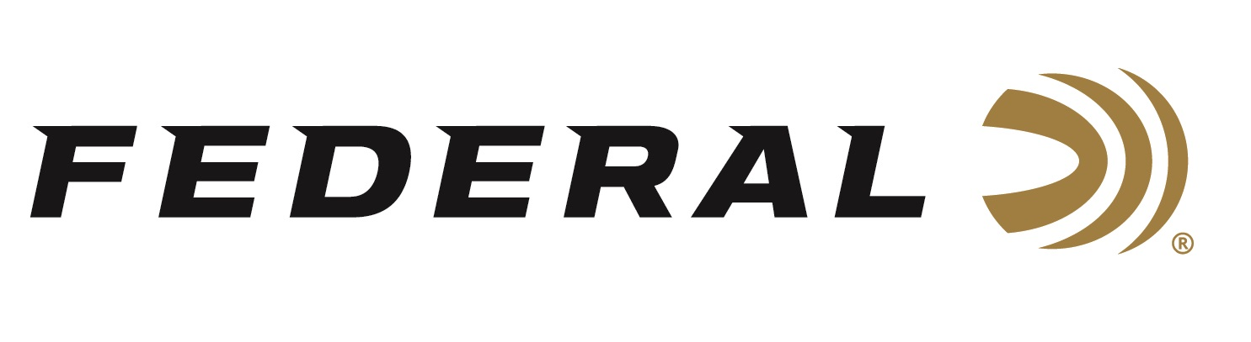

FOR IMMEDIATE RELEASE

Team Federal Lands Three Top Shooters on U.S. National Trap Teams

ANOKA, Minnesota – June 4, 2026 – Three Olympic hopefuls and current Federal sponsored shooters have qualified for the 2026 U.S. National team in Trap following the Shotgun National Championships. 2020 silver medalist Kayle Browning, 2020 bronze medalist Brian Burrows, and two-time Olympian Derrick Mein earned the designation after their performances at Hillsdale College in Hillsdale, Michigan during the championships. The event ran from May 23-27, 2026.

“It was a great competition, and I’m very happy with my performance and the outcome,” said Brian Burrows. Burrows won a bronze medal in Mixed Team Trap at the 2020 Olympic Games in Tokyo. “Nationals was an important step forward because it confirmed the work I’ve been putting in is translating into results in competition,” says Burrows. “It also keeps me in a strong position as I continue pursuing a spot on future World Championship and Olympic teams.” Burrows reports that in addition to making another National Team, he has qualified for World Cup events in Italy and China and is currently sitting in second place heading into the World Championship Selection Match this September.

“The World Championships in Qatar will be especially important,” states Burrows. It is the first opportunity for countries like the U.S.A. to earn quota places for the 2028 Olympic in Los Angeles. “My goal is absolutely to make a run at LA in 2028. It would be incredibly special to compete in an Olympic Games held in the United States, especially on one of the ranges where I grew up shooting,” says Burrows.

Derrick Mein continues his qualification streak for the U.S. Men’s National Trap team. He has qualified every year since 2018. Kayle Browning has been a fixture on the U.S. Women’s National Trap Team since the age of 15.

Federal Ammunition products are available at dealers nationwide and online. For more information on all Federal products and to sign up to receive notifications about new product availability, rebate promotions, and other brand news via email, visit www.federalpremium.com.

Press Release Contact: JJ Reich
Senior Manager – Press Relations
E-mail: media@tkghunt.com

About Federal Ammunition
Federal, headquartered in Anoka, MN, is an ammunition brand of The Kinetic Group, owned by CSG, a globally diversified industrial group based in Prague, Czech Republic. Since 1922, Federal has been a leader in ammunition innovation, delivering high-quality sporting and hunting products to shooters worldwide. With a commitment to conservation and the outdoor community, Federal continues to manufacture industry-leading ammunition that enhances the shooting experience while supporting outdoor traditions.

